**SUBSTATION MAINTENANCE INSPECTION GUIDELINE**

"Start the Maintenance Substation Inspection application"

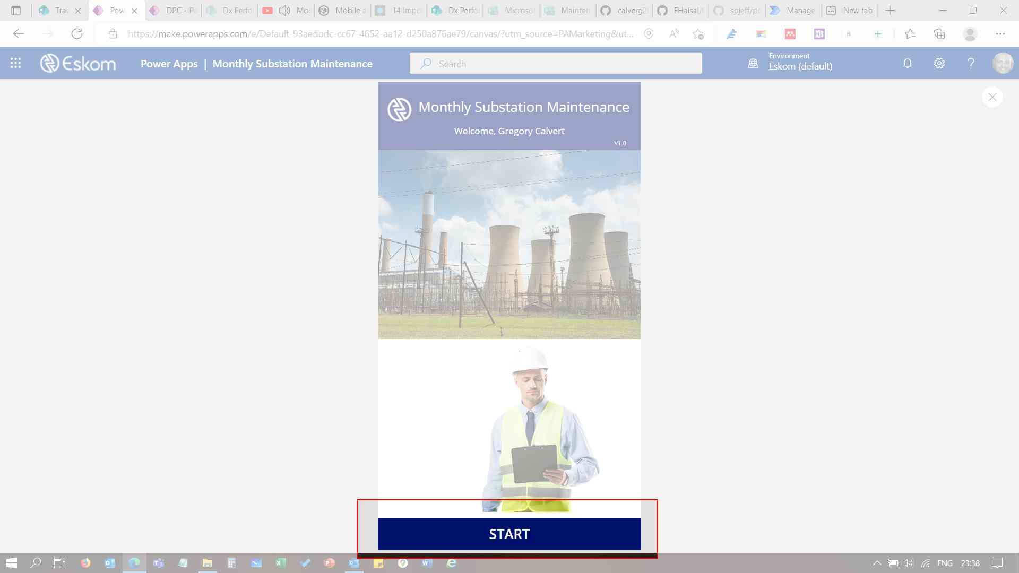

"Select the Sector, CNC, Substation and workorder to start inspection"

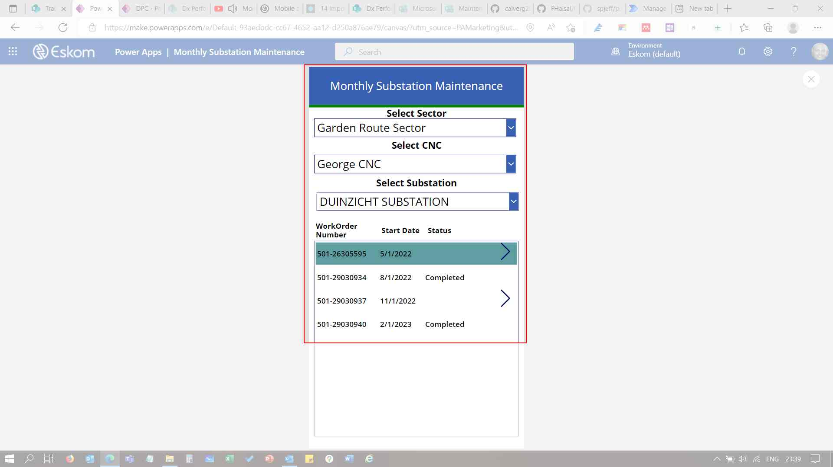

"Substation Facilities screen with selected W/O selected. Back button. Number of Questions and completed questions. Home button."

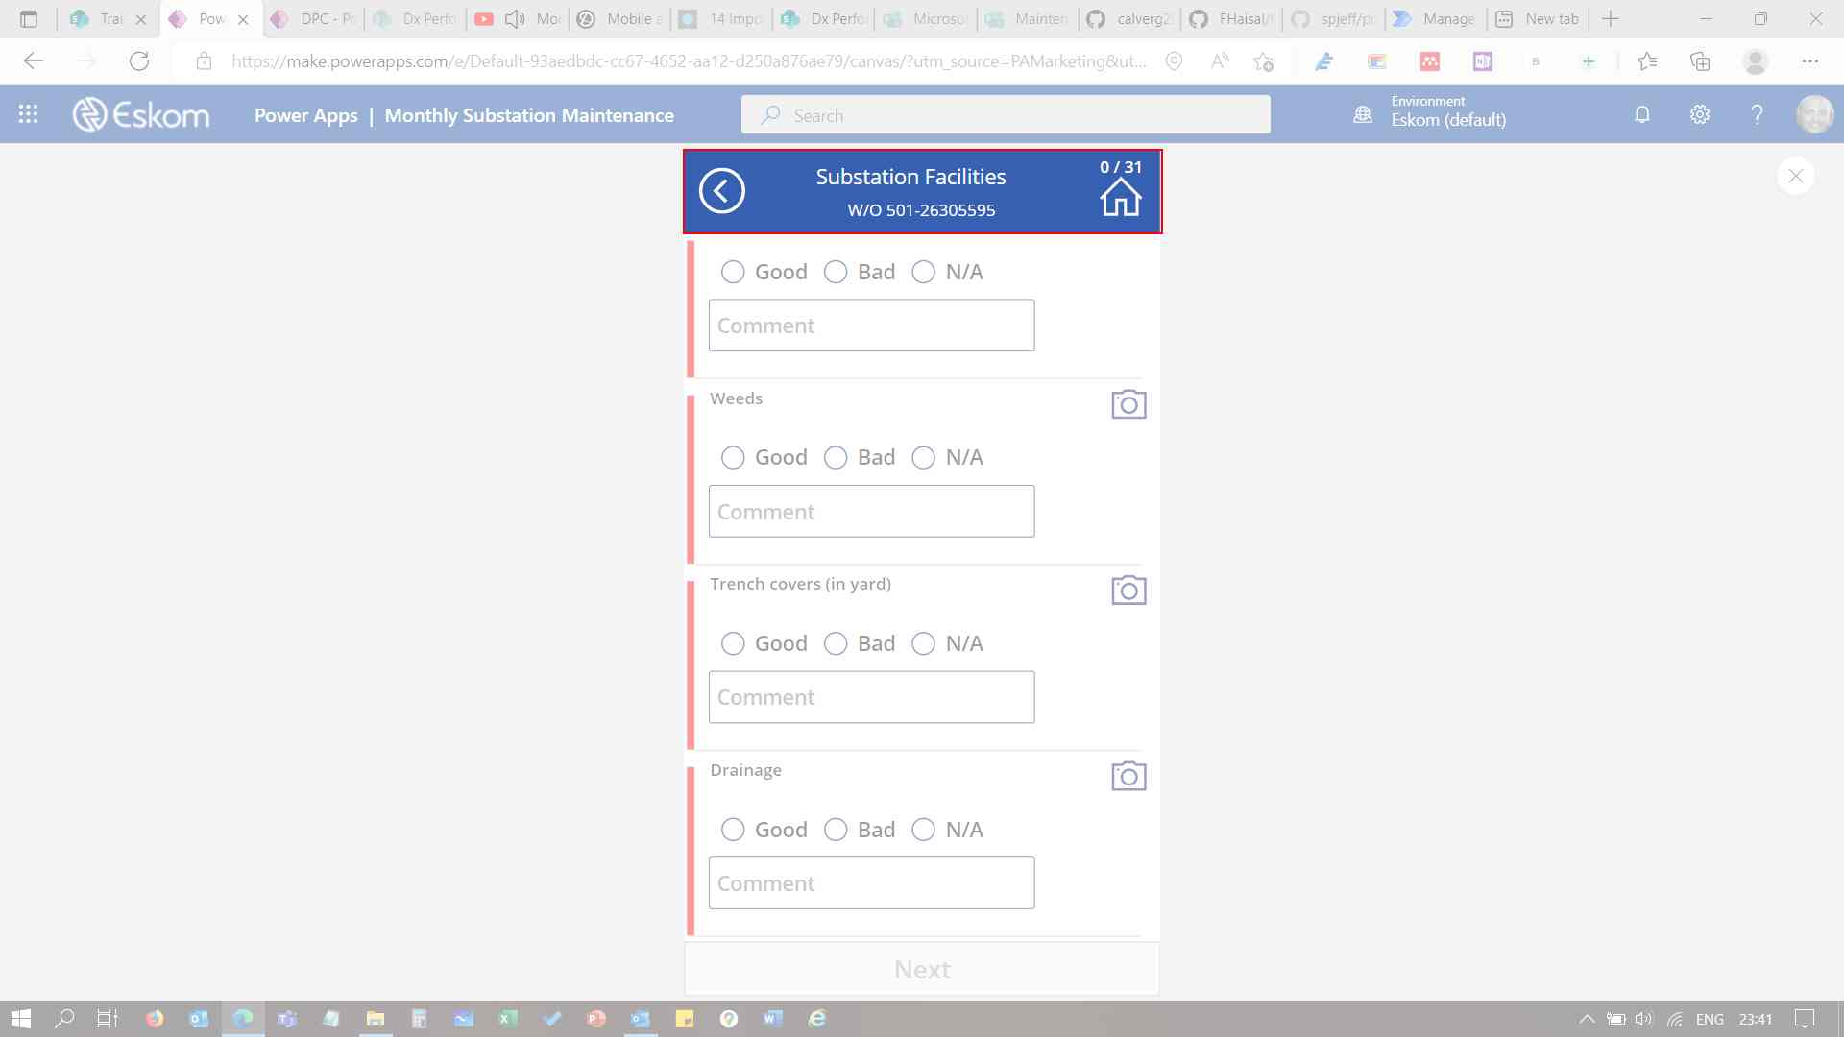

"Completed question indicator. Question status selection Comment. Camera Selection."

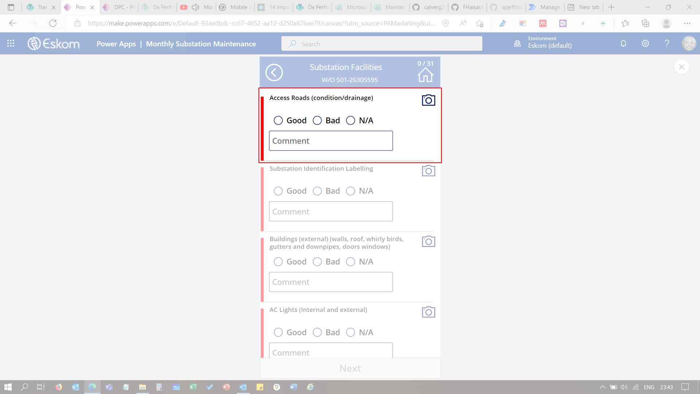

"To add a bay or feeder or select inspection completed"

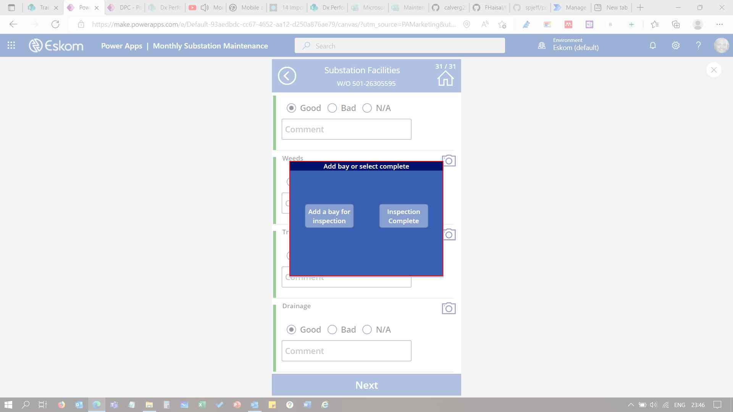

"Input Bay or Feeder Name"

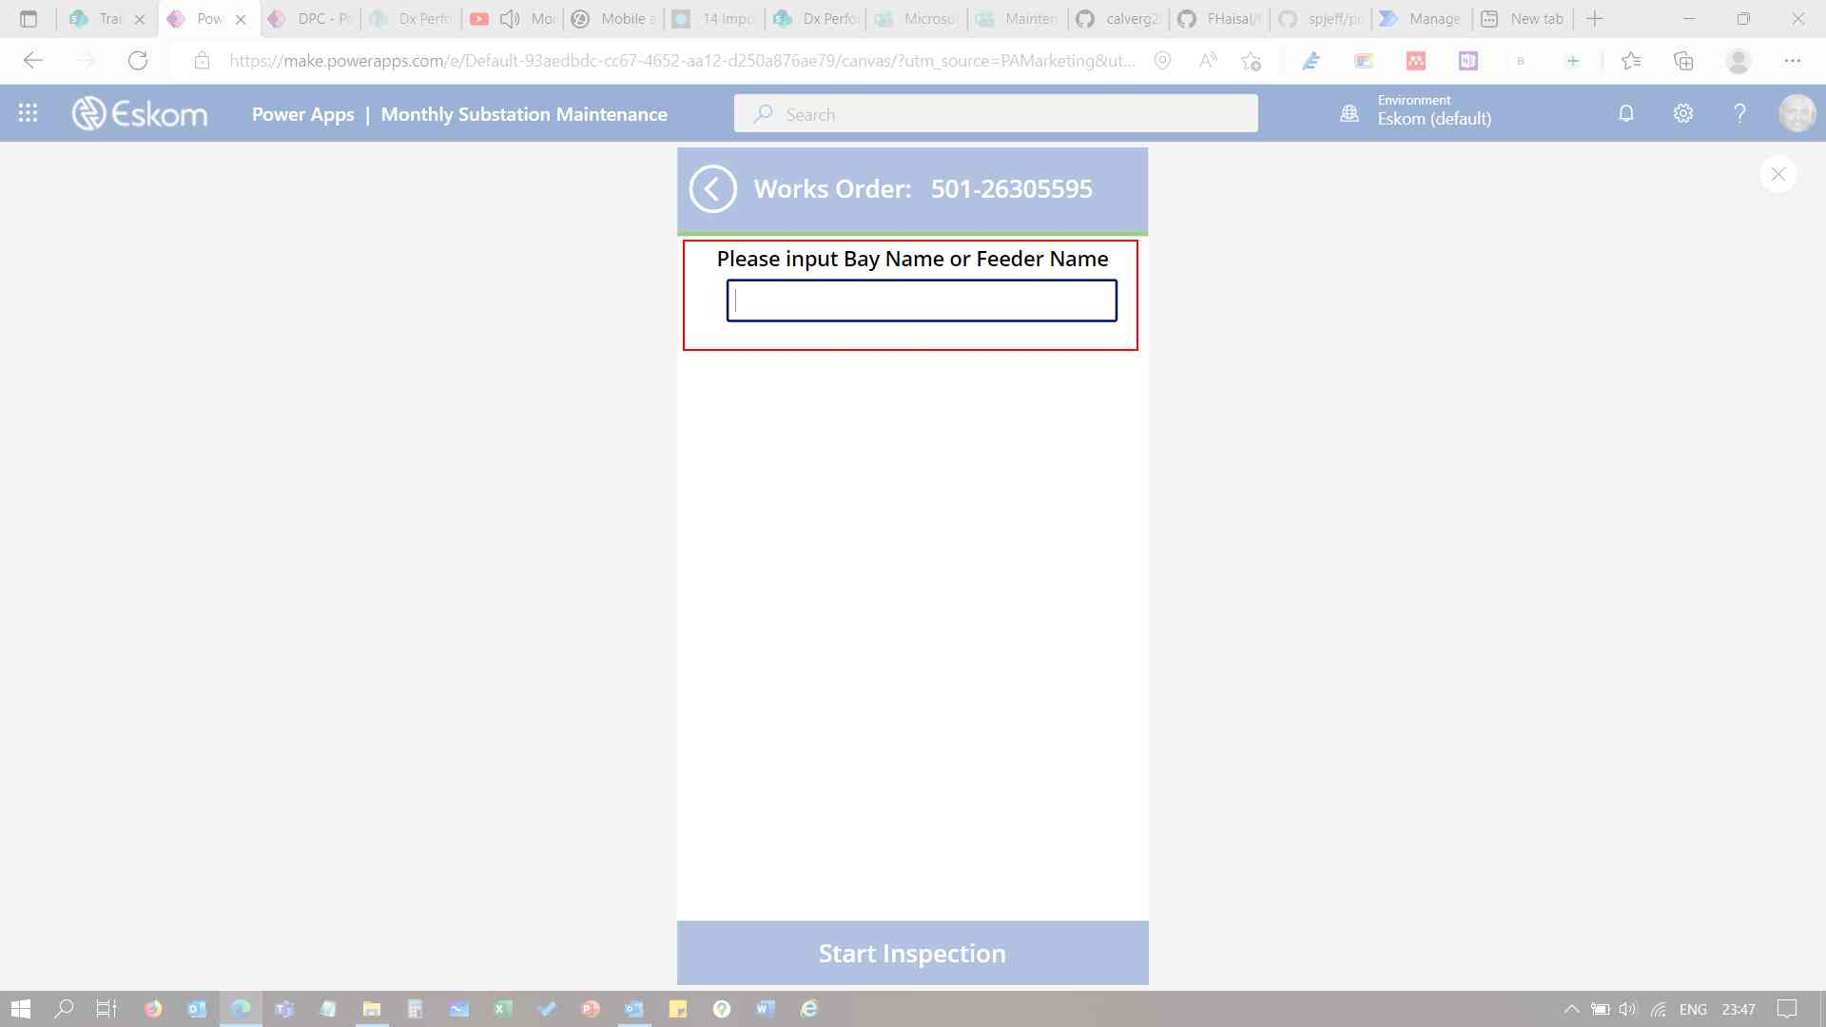

"Inspection area selection only visible when name is entered"

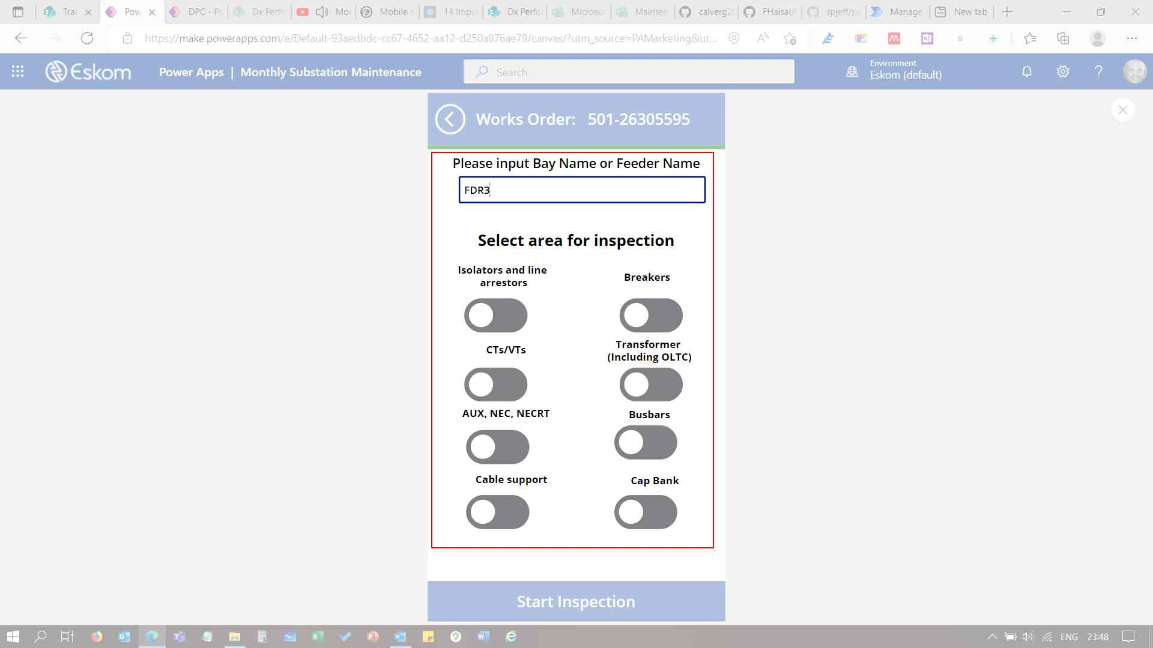

"Start Inspection button."

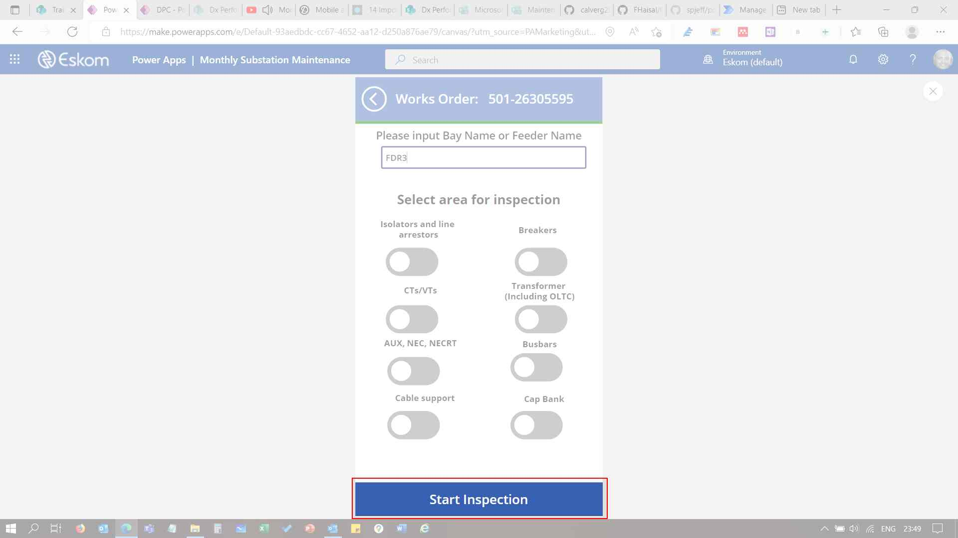

"Confirmation 'Save Inspection' popup screen"

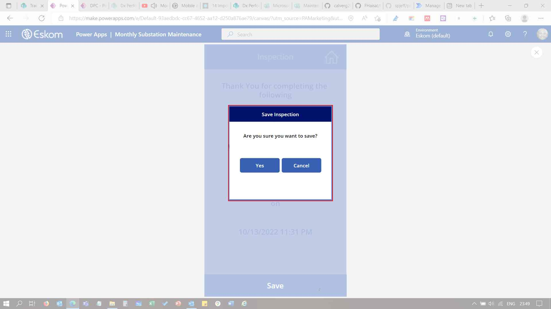

"Work order completed confirmations screen"

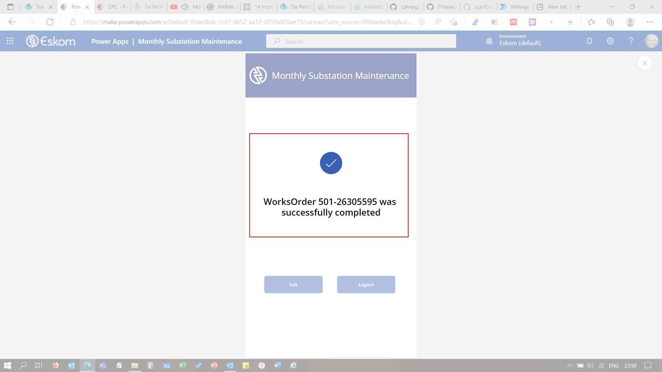

"Exit or Logout buttons visible.

Exit - Keeps user logged in PowerApps and ready for next inspection.

Logout - User is logout and new user can log in"

